**Homework Assignment 5**

Due: 11:59PM June 22, 2021

1. Navigate the data

(a) Execute the following queries (on either Hive or Impala) and report the results.

- SHOW DATABASE;

- SELECT * FROM toy.toys;

- SELECT CONCAT(first_name, ' ', last_name) AS NAME, office_id

FROM default.employees;

- SELECT * FROM default.orders WHERE total > 25;

- SELECT employees.last_name, employees.office_id, city, state_province, country

FROM employees JOIN offices ON employees.office_id = offices.office_id;

(b) Execute the following queries on both Hive and Impala, and explain the difference in terms of the results and performances.

- SELECT id, name, price + 5 FROM toy.toys;

(Hive)

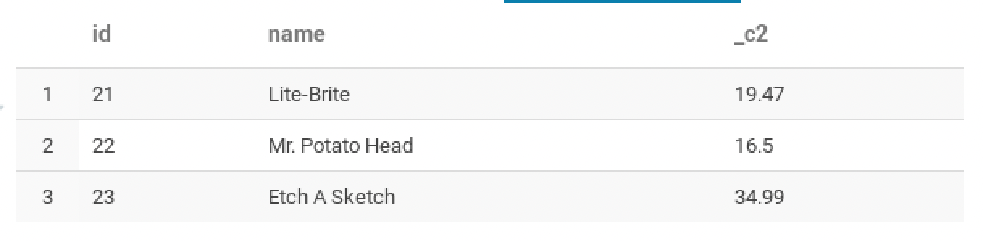

(Impala)

(difference in terms of the results and performances)

Hive doesn't show the same data, Impala shows everything. Also, the Impala has much faster performance.

- SELECT id, name, ROUND(price*1.1,2) FROM toy.toys;

(Hive)

(Impala)

(difference in terms of the results and performances)

Impala is faster than Hive. And the column name can change in Impala.

- SELECT COUNT(*) FROM wax.crayons;

(Hive)

(Impala)

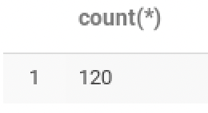

(difference in terms of the results and performances)

Impala is faster than Hive. And have different column name.

- SELECT red + green + blue AS SUM_RGB

FROM wax.crayons ORDER BY SUM_RGB DESC LIMIT 10;

(Hive)

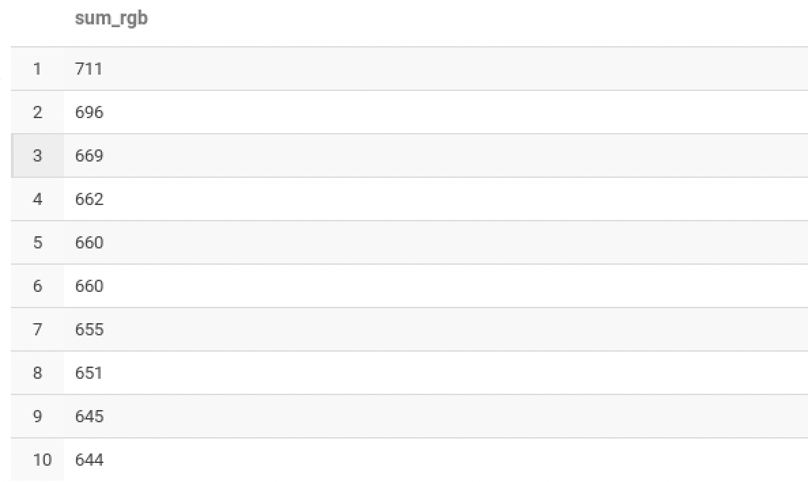

(Impala)

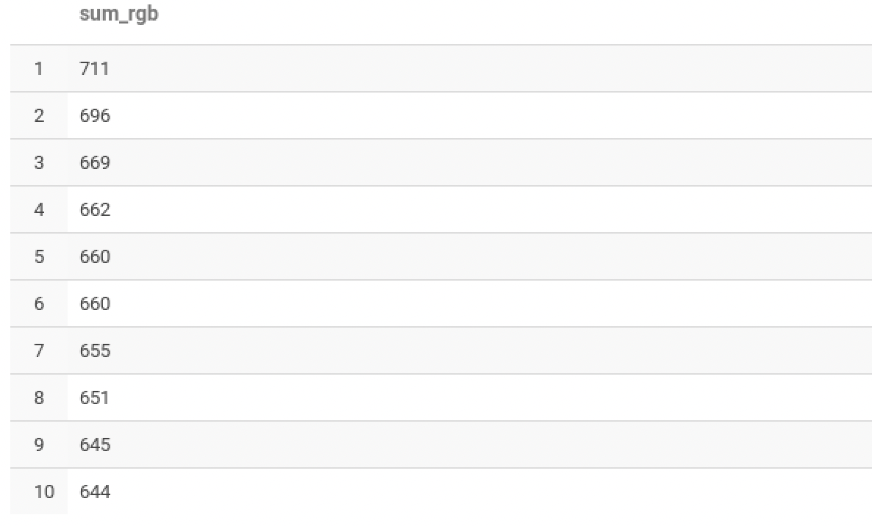

(difference in terms of the results and performances)

Impala is faster than Hive.

- SELECT order_id, name AS cust_name, last_name AS empl_name

FROM default.orders

JOIN default.customers ON orders.cust_id = customers.cust_id

JOIN default.employees ON orders.empl_id = employees.empl_id

WHERE total < 0;

(Hive)

(Impala)

(difference in terms of the results and performances)

Impala is faster than Hive.

- SELECT order_id, name AS cust_name, last_name AS empl_name

FROM default.orders

JOIN default.customers ON orders.cust_id = customers.cust_id

JOIN default.employees ON orders.empl_id = employees.empl_id

ORDER BY total;

(Hive)

(Impala)

(difference in terms of the results and performances)

Hive doesn’t allow order by. However, Impala allow order by.

- difference between Hive and Impala

From a result & performance point of view, there is a noticeable difference between impala and hive.

First, impala is a system that can analyze data stored in HDFS in real time using SQL. Therefore, it provides very fast results because analysis is performed using a distributed query engine without using the MapReduce framework.

In addition, the CPU load is reduced and the I/O response time is reduced, so the performance is also very good.

However, Hive uses the Mapreduce framework and is about data inquiry interface, so the speed of data analysis work is not high. Therefore, it gives slower results compared to impala.

2. From 3(a) of the worksheet, report the result of each query on Impala. Add your analysis & interpretation about the results.

(a) GROUP BY queries

- SELECT year, COUNT(*), ROUND(AVG(dep_delay),1), ROUND(AVG(arr_delay),1)

FROM flights

GROUP BY year

ORDER BY year;

(analysis & interpretation about results)

impala provides round() function. However, as a result of searching on Google, it seems that it is not displayed properly due to a client problem. This query means average dep_delay and average arr_delay during flight during the same year. Based on this, it can be seen that the overall delay in 2012 is small and dep_delay is larger than arr_delay.

- SELECT month, COUNT(*), ROUND(AVG(dep_delay),1), ROUND(AVG(arr_delay),1)

FROM flights

GROUP BY month

ORDER BY month;

(analysis & interpretation about results)

impala provides round() function. However, as a result of searching on Google, it seems that it is not displayed properly due to a client problem. This query returns the number of flights, average dep_delay, and average arr_delay for the same month. Based on this, it can be seen that November has the smallest delay, and similarly to the previous problem, dep_delay is larger than arr_delay.

- SELECT FLOOR(dep_time/100) AS DEP_HR, COUNT(*), ROUND(AVG(dep_delay),1)

FROM flights

GROUP BY DEP_HR

ORDER BY DEP_HR;

(analysis & interpretation about results)

impala provides round() function. However, as a result of searching on Google, it seems that it is not displayed properly due to a client problem. This query shows the number of delays and dep_delay time in the same time zone.

Based on this, the average number of delays the most is in the 8am time zone, but the longest delay time on average is 2am.

- SELECT origin, COUNT(*), ROUND(AVG(dep_delay),1) AS DEP_DLY

FROM flights

GROUP BY origin

ORDER BY DEP_DLY DESC;

ans so on…

(analysis & interpretation about results)

impala provides round() function. However, as a result of searching on Google, it seems that it is not displayed properly due to a client problem. This query shows the number of flights to each region and the average dep_delay time. Based on this, ENW, SWO, TKI, and BFF have the smallest number of delays with 1, and ACV has the largest number of delays. On the contrary, it can be seen that the number of delays and the average delay time are inversely proportional. It may mean that the number of planes is small, and thus the number of customers who use the planes may also be small.

- SELECT carrier, ROUND(AVG(dep_delay),1) AS DEP_DELAY,

ROUND(AVG(arr_delay),1) AS ARR_DELAY

FROM flights

GROUP BY carrier

ORDER BY ARR_DELAY DESC;

(analysis & interpretation about results)

impala provides round() function. However, as a result of searching on Google, it seems that it is not displayed properly due to a client problem. This query shows the average dep_delay time and average arr_delay time of each carrier in descending order of arr_delay. When analyzing the results based on this, if dep_delay is longer than arr_delay, it means that the plane was definitely overspeeding or it took a little less than the original flight time. It can also be seen that overall dep_delay is longer than arr_delay.

- SELECT carrier, ROUND(AVG(dep_delay),1) AS DEP_DELAY,

ROUND(AVG(arr_delay),1) AS ARR_DELAY

FROM flights

GROUP BY carrier

ORDER BY DEP_DELAY DESC;

(analysis & interpretation about results)

impala provides round() function. However, as a result of searching on Google, it seems that it is not displayed properly due to a client problem. This query shows the average dep_delay time and average arr_delay time of each carrier in descending order of dep_delay. When analyzing the results based on this, if dep_delay is longer than arr_delay, it means that the plane was definitely overspeeding or it took a little less than the original flight time. It can also be seen that overall dep_delay is longer than arr_delay.